Marine Fisheries Management, History, Techniques, and Impact Unit

Use the internet and maps to answer the following questions

- Name the top 5 consumers of fish per capita in the world.
1 _________________
2 _________________
3 _________________
4 _________________
5 _________________

- The locations listed below are the greatest fisheries in the world for total fish production. For each location, examine a map and describe what geographical and ecological features they share in common.

North Sea | Grand Banks (near Newfoundland) | Gulf of Alaska | New Zealand | Sea of Okhotsk

- The average American eats ___________ pounds of fish per year (per capita).

- One in ten fish caught is eaten in __________________.

- Marine sources represent _________ % of the world’s protein consumption.

- Look at the graph. Explain what this data represents.

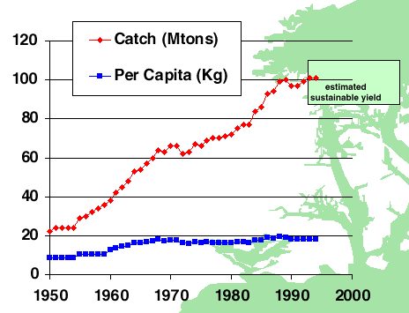

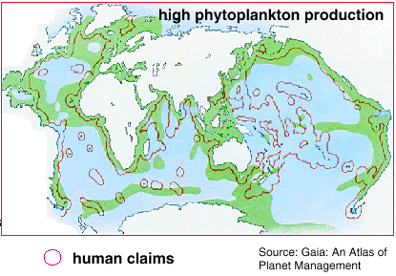
- Examine the map below. Green areas represent areas of high productivity. Name three areas where there would be large fish stocks without government claims?

- Examine the table below.

Species | Peak Year | Peak Catch | 1992 Catch | Percent Change
Pacific herring | 1964 | 0.7 | 0.20 | -71%
Atlantic herring | 1966 | 4.1 | 1.50 | -63%
Atlantic cod | 1968 | 3.9 | 1.20 | -69%
So. African Sardines | 1968 | 1.7 | 0.10 | -94%
Haddock | 1969 | 1.0 | 0.20 | -80%
Peruvian anchovy | 1970 | 13.1 | 5.50 | -58%
Polar cod | 1972 | 0.35 | 0.02 | -94%
Cape hake | 1972 | 1.1 | 0.20 | -82%
Silver hake | 1973 | 0.43 | 0.05 | -88%
Yellow croaker | 1974 | 0.20 | 0.04 | -80%
Atlantic redfish | 1976 | 0.7 | 0.30 | -57%
Chub mackerel | 1978 | 3.4 | 0.90 | -74%
Blue whiting | 1980 | 1.1 | 0.50 | -27%
So. American Sardines | 1985 | 6.5 | 3.10 | -52%
Alaska pollock | 1986 | 6.8 | 0.50 | -26%
North Pacific hake | 1987 | 0.30 | 0.06 | -80%
TOTALS (in millions) | --- | 51.48 | 21.77 | -58%

- What is the most caught fish in the world?

- Which fish have seen the greatest total decline in catch since their peak?

- Which fish have seen the great percentage in decline since their peak?

- Which fish has seen the least decline?
- Explain what aquaculture is and what effects it may have on overfishing.

- Give 5 species of fish that are commonly harvested via aquaculture. Has the use of aquaculture reduced the declines of these species in the wild?

- What are the risks/disadvantages of the use of aquaculture? Give a minimum of three and explain why.

